EBU6304 Software Engineering Group Project

2025-26
Group number
member 1 | QM no: 231225731 | Name: Zijie Zhang
member 2 | QM no: 231225270 | Name: Zijun Song
member 3 | QM no: 231225672 | Name: Siying Li
member 4 | QM no: 231225557 | Name: Lingxiang Mei
member 5 | QM no: 231225339 | Name: Lechen Ning
member 6 | QM no: 231225649 | Name: Zhenkun Li

First report

1.Requirements

1.1 Fact-finding techniques
To accurately capture the core needs of target users (applicants and professors) for the TA recruitment management system, our group adopted a combination of three fact-finding techniques to ensure comprehensiveness and authenticity of requirements.

1.1.1 Online searching
We searched for complaints and feedback about the existing educational administration system in online forums and comment sections of related educational videos. Compared with formal interviews or inquiries, people are more relaxed in online environments and more willing to express their true feelings instead of perfunctory responses. For example, some professors hope to simplify the approval process for TA-related matters to complete approvals quickly and avoid work delays.

1.1.2 Stakeholder interviews
Our group members conducted two-way communication with key stakeholders: we sent emails to each course teacher to solicit their opinions on the existing TA management system, and also held exchanges with current and former TAs to discuss the functions, advantages and disadvantages of current TA recruitment methods, areas for improvement, and practical issues in the process. The feedback we collected was the most direct; some teachers had strong reactions, and these are the key issues we need to focus on solving. For example, being able to quickly know who enrolled in his course is an urgent need for our module's professor—this is a basic and reasonable requirement. Meanwhile, TAs pointed out that unclear vacancy information and tedious application steps have increased their application burden, which guided us to refine relevant user stories.

1.1.3 Document analysis
We first analyzed existing materials related to QMUL’s TA recruitment process, including historical recruitment notices and manual application forms. This helped us identify pain points in the traditional process, such as repeated input of personal information, unclear vacancy information, and inefficient email-based CV submission. For example, the lack of real-time status tracking for applications led to frequent inquiries from applicants, which laid the foundation for defining user stories like "Application Status Tracking" (TA_08).

1.2 Iteration (Sprint) Plan
Based on the Agile development methodology, we divided the project into 4 sprints, with clear goals, deliverables, and timeframes aligned with the user story priorities and estimation:
Sprint Number | Duration | Core Goals | Corresponding User Stories | Deliverables
Sprint 1 | Week 1-2 | Complete core functions for all roles (TA/Professor/Admin) to ensure basic system operation | Must-have stories: TA_01 (Personal Profile Management), TA_02 (Vacancy Browsing & Filtering), TA_04 (Password Reset)  PF_01 (Manage TA's Work), PF_02 (View Questionnaire Submissions), PF_03 (User Registration & Role Selection)  AD_01 (Monitor Overall TA Workload), AD_02 (Manage System Users), AD_03(Oversee Job Postings) | - Functional prototypes of core modules (TA/Professor/Admin)  - User role & vacancy data models design  - Basic UI framework with role-based access
Sprint 2 | Week 3-4 | Implement supplementary functions to improve efficiency for all roles | Should-have stories: TA_03 (Integrated Submission), TA_06 (Document Preview Before Upload)  PF_04 (Simplify Approval Process), PF_05 (Optimize UI Design), PF_07 (Applicant CV Review), PF_08 (Applicant Selection & Approval)  AD_04 (View Basic Application Stats), AD_05 (Export Core System Data), AD_11 (Search Users/Jobs), AD_13 (View Individual User Details) | 1. Document preview & integrated upload module  2. Streamlined approval workflow (with notifications)  3. Data analysis toolkit & optimized UI components
Sprint 3 | Week 5-6 | Add optional functions to enhance system flexibility & user experience | Could-have stories: TA_05 (Application Deadline Reminder), TA_07 (Save as Draft), TA_08 (Application Status Tracking), TA_09 (Application Withdrawal)  PF_06 (Increase System Stability), PF_09 (Increase System Security), PF_10 (Password Management)  AD_06 (View System Key Event Log) , AD_07 (Send Bulk Notifications (Simulated)) , AD_10 (Reset User Password) , AD_12 (View Job Application Status Summary) | 1. UX enhancement suite(reminders/drafts/withdrawal)  2. Performance monitoring dashboard  3. Security modules (password management/logging)
Sprint 4 | Week 7-8 | Implement advanced optimization and system integration | Want-to-have story: TA_10 (Preference Selection)  PF_11 (Support Mobile Device), PF_12 (Support Different Course Types)  AD_08 (Configure Recruitment Cycle Dates), AD_09 (Assign Basic User Roles) | - Advanced modules (preference matching/mobile adaptation)  - System integration toolkit (backup/configuration)  - End-to-end test report & comprehensive docs

1.3 Prioritisation Method
We adopted the MoSCoW Method to prioritize user stories, ensuring that critical needs are addressed first while balancing feasibility and user value. The prioritization criteria include: business necessity, user pain point severity, and technical implementation difficulty.
Priority Level | Definition | Distribution of User Stories | Rationale
Must-have | Core functions without which the system cannot operate | TA_01, TA_02, TA_04, PF_01, PF_02, PF_03, AD_01, AD_02, AD_03 | These functions cover basic user access (registration, password reset), core service scenarios (vacancy browsing, TA management), and are prerequisites for subsequent functions.
Should-have | Important functions that significantly improve user experience but are not mandatory | TA_03, TA_06, PF_04, PF_05, PF_07, PF_08, AD_04,AD_05, AD_11, AD_13 | These functions address key pain points (e.g., integrated CV submission replaces inefficient email transmission) and align with stakeholder feedback, with moderate technical difficulty.
Could-have | Optional Optional functions that enhance flexibility but can be deferred | TA_05, TA_07, TA_08, TA_09, PF_06, PF_09, PF_10, AD_06,AD_07, AD_10, AD_12 | These functions improve user experience (e.g., draft saving) but are not critical to the core process; they can be added after the basic system is stable.
Want-to-have | Nice-to-have functions with low priority and high implementation cost | TA_10, PF_11, PF_12, AD_08, AD_09 | Preference selection requires complex matching logic and is not urgent for initial launch; it can be implemented in the final sprint if resources allow.

1.4 Estimation Methods
To ensure a realistic development schedule and maintain team velocity, we employed a formal Relative Sizing approach rather than absolute time estimation. This methodology minimizes the "planning fallacy" by focusing on the complexity, effort, and risks associated with each User Story.

1.4.1 The Fibonacci Scale and Story Points
We adopted the Fibonacci Sequence (1, 2, 3, 5, 8, 13) to assign Story Points. The non-linear nature of this scale is crucial: as the complexity of a task increases, the uncertainty grows proportionally.
- Smaller values (1-5): Represent well-defined, low-risk tasks.
- Larger values (8-13): Signal "Epics" or stories that require decomposition due to high technical uncertainty or extensive data handling.

1.4.2 Triangulation and Reference Stories
To maintain consistency, the team established Reference Stories (baselines) to "triangulate" the size of new requirements:
- Baseline (3 Points): We defined a standard "CRUD" operation—such as AD_13: View Individual User Details or TA_02: Vacancy Browsing—as a 3-point task. These involve straightforward data queries and basic UI rendering with minimal logic.
- Comparative Scaling: Stories with more "moving parts" were scaled upward. For example, TA_01: Personal Profile Management (5 points) was rated higher than the baseline because it requires form validation, persistent state management, and data integrity checks across sessions.

1.4.3 Planning Poker Protocol
To avoid "anchoring bias" (where junior members follow the lead of senior developers), we conducted Planning Poker sessions for each story in the backlog:
- Independent Assessment: Each team member privately selected a card representing their estimate.
- Revealing & Outlier Discussion: If estimates differed significantly (e.g., one member voted 3 and another 8), the "outliers" explained their reasoning.
Example Case: For TA_03: Integrated Submission, the initial range was 5 to 13. The developer who voted 13 pointed out the risks of file type validation (.pdf/.docx) and the complexity of linking binary storage to the SQL database. After discussion, the team reached a consensus of 8 points, acknowledging the technical overhead while streamlining the UI requirements.
- Consensus: The final point was only assigned once the whole team agreed on the story's scope and acceptance criteria.

1.4.4 Velocity and Iteration Capacity
By aggregating these points, we calculated the total "Weight" of each Sprint.
- Sprint 1 (49 points): Focuses on stable, medium-complexity core features to establish our initial Velocity.
- Sprint 2 (41 points): Leveraging the infrastructure built in Sprint 1, we plan to handle higher-complexity tasks.
- Sprint 3 (52 points): Focuses on administrative management tools and "Could-have" features to refine the overall user experience and oversight capabilities.
- Sprint 4 (26 points): Dedicated to "Hardening," including final bug fixing, security auditing, and documentation to ensure the system meets the "Definition of Done" for final delivery.
This aggregation allows us to monitor if the team is over-committed or under-utilized, ensuring a sustainable pace as mandated by Agile principles.

2.Supporting material
Include supporting materials, such as interview questions, survey results, and customer feedback etc (if applicable).(最后删掉！！)

2.1 TA side

1. Hands-on experience: The teaching assistant sent our team members the link for using this system from the TA side, and our members actually tried it out and summarized some areas for optimization. The website is " https://forms.office.com/e/9B2VdDqmnz". The interface is as below.

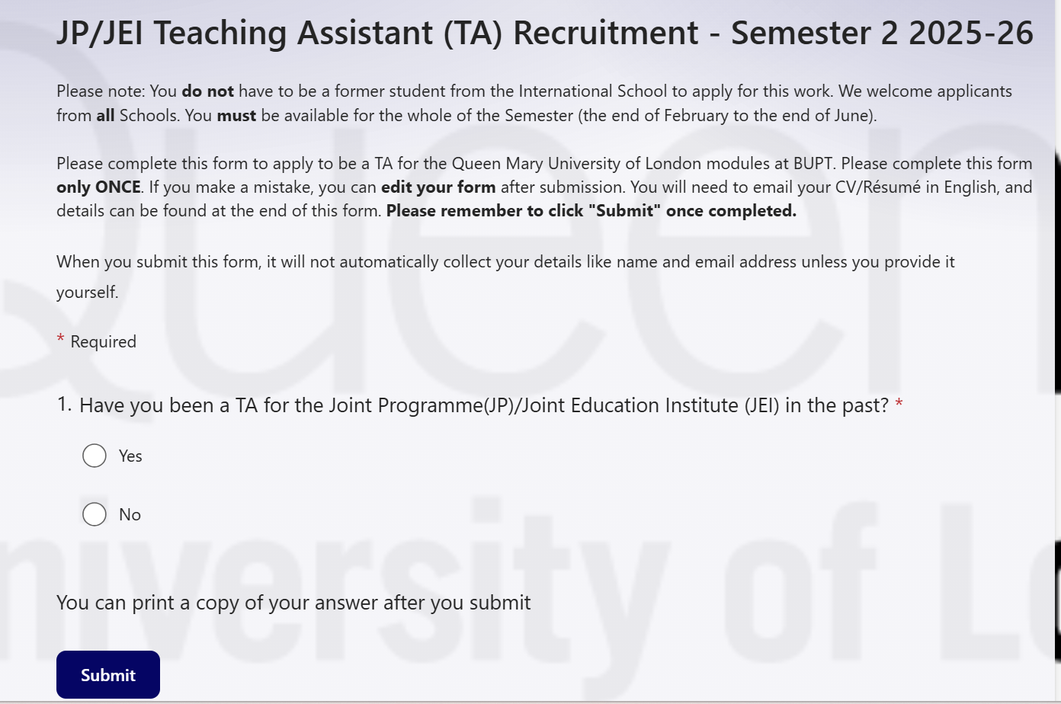
- Interview: We interviewed our TAs and note their concerns in Chinese.

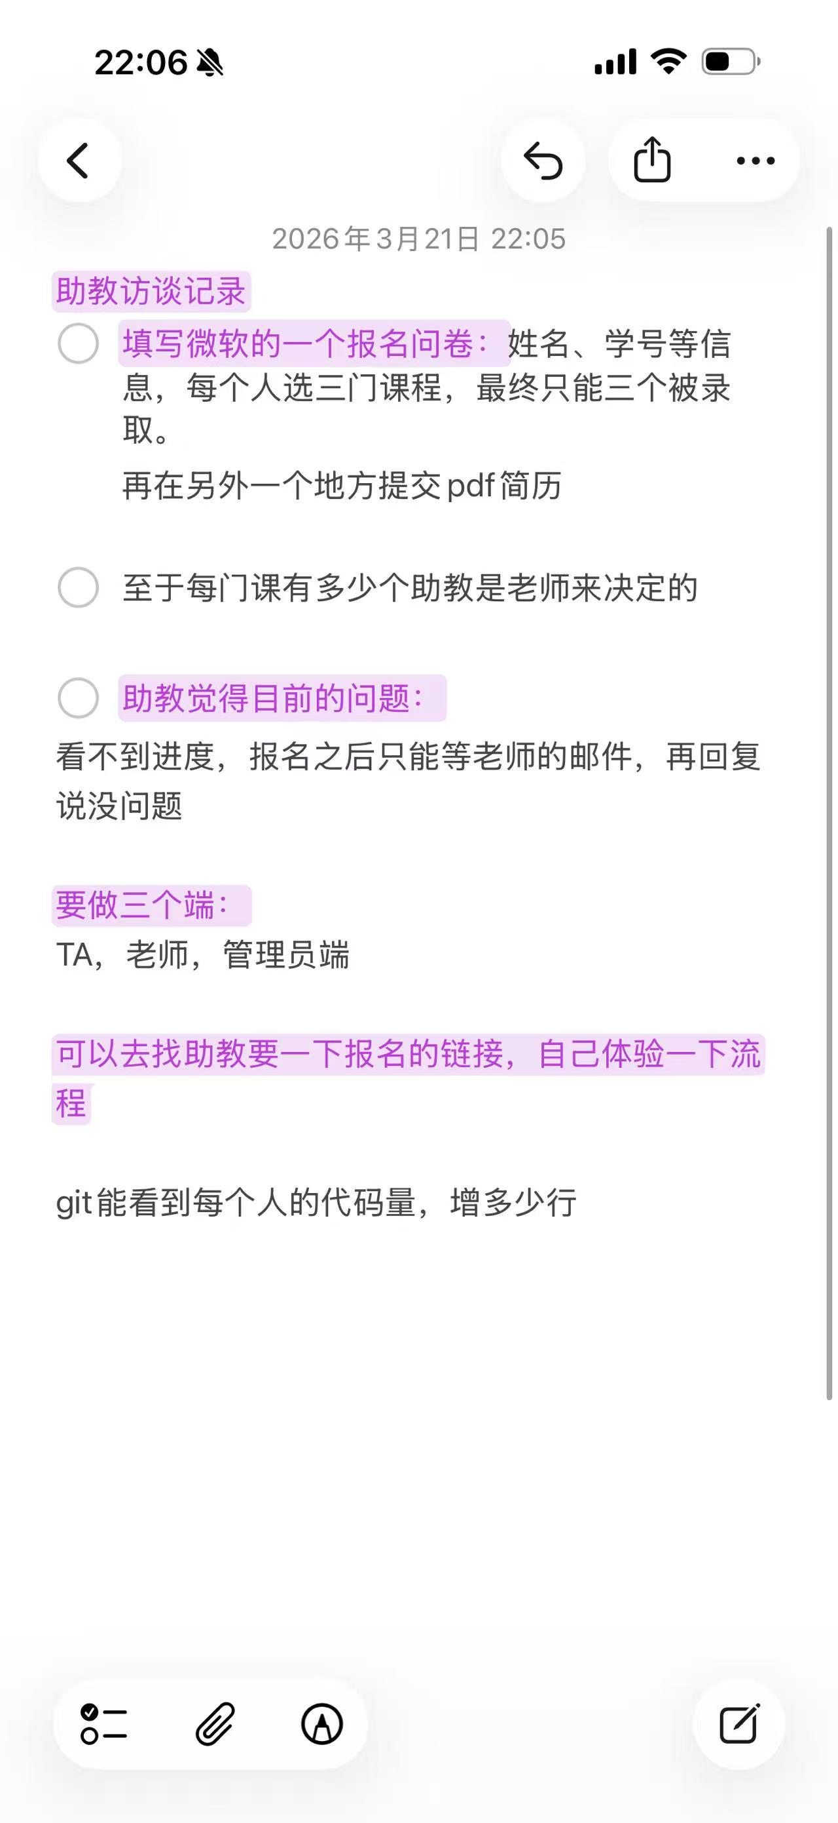

2.2 Professor side

1. Email：We emailed our teacher to get his opinions on current system, like the picture below.

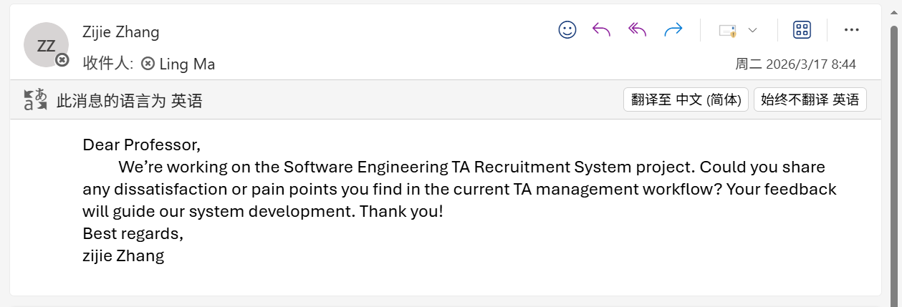

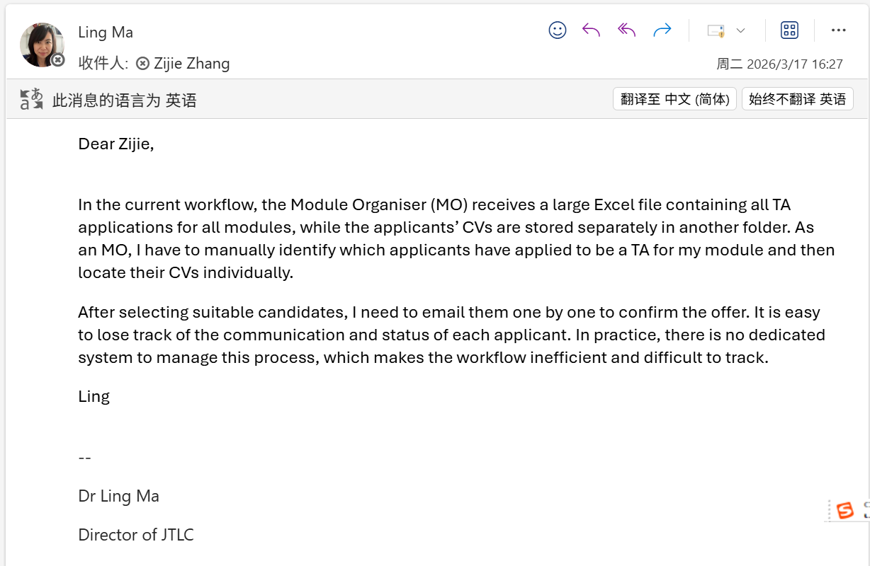
- Online search. We have collected some teachers’ complaints about this teaching assistant management system from online forums. Some comments are as follows:
- The system is such a headache. Half the time I can’t even submit my hours correctly, and the interface is so clunky I have to click through five pages just to do one simple thing. Who designed this?!
- Every semester I dread filling out TA info in this system. It’s slow, confusing, and never works on the first try. Support never helps either. Just let us use a simple spreadsheet — it would be more reliable!

2.3 Administrator side

1.To quickly validate administrator-side requirements, we conducted a lightweight observation of 1–2 existing education/recruitment admin dashboards.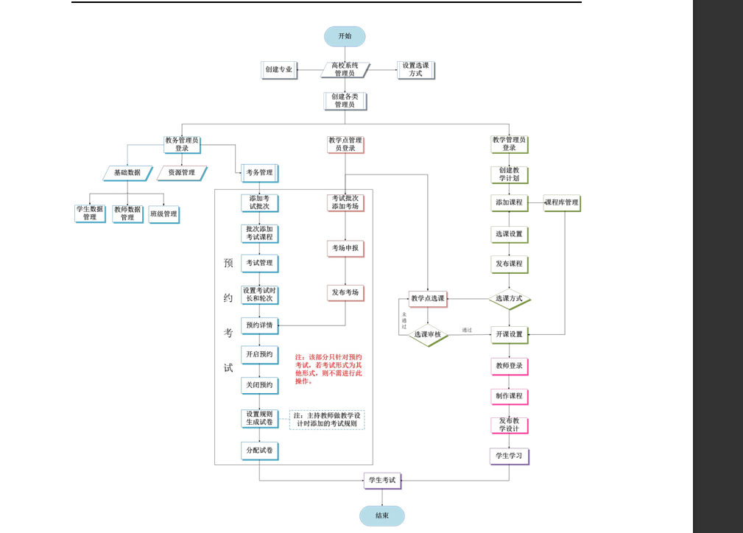

2.We used the Questionnaire Star mini-program to create surveys and distributed them to teachers and students to gather requirements for the administrator . 